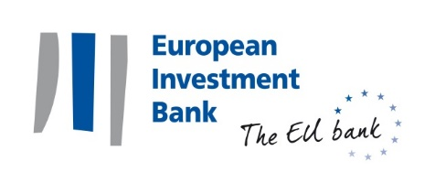
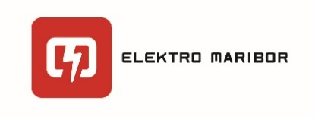

PRESS RELEASE

2019-XXX-EN

Luxemburg / Maribor

26 May 2019

EIB lends EUR 31 million to Slovenian Elektro Maribor to increase reliability of electricity distribution in North East Slovenia
- Elektro Maribor to further increase stability of electrical distribution and develop electrical infrastructure for more than 219.000 users in North Eastern Slovenia;
- Loan supports Elektro Maribor improve quality of service, reliability of its network, and minimize blackouts and blackout-related damages to property and environment;
- The loan allows for introduction of advanced metering system to optimise future investments and reduce technical and commercial losses;
The European Investment Bank signed a EUR 31 million loan with Elektro Maribor, electricity distributor from Slovenia`s second largest city of Maribor; the loan will go towards maintenance or improvements in the reliability and in quality standards of electricity supply. The EIB loan supports Elektro Maribor`s EUR 81,2 million investment in reconstruction and development of its electricity distribution network in order to minimise power blackouts and blackout-related damage to property and environment.
To date, the EIB invested EUR 170.5 million in electric power distribution projects in Slovenia, bringing the total amount of its investments in Slovenia to EUR 6.87 billion.
Elektro Maribor will be able to reinforce and refurbish high, medium and low voltage networks, as well as expand the national electric grid with connection of new users and the integration of renewable energy generation. Investment will allow introduction of advanced metering systems, improving the collection of data and optimisation of investments, together with reduction of technical and commercial losses.
Liliana Pavlova, Vice President of the EIB, said: “This EIB investment delivers a more reliable electric distribution network in Slovenia and therefore improves the quality of life for thousands of Slovenians as well as conditions for doing business in the country. Reliable power supply is also crucial for the country`s resilience in major crisis such as the covid-19 pandemic. The European Investment Bank is happy to support this investment by Elektro Maribor and continue with supporting Slovenia develop further”.
Boris Sovič, CEO of Elektro Maribor, said: “Elektro Maribor and the European Investment Bank have been cooperating very successfully since 2015. With its own resources and with the help of EIB funds, Elektro Maribor has increased the level of network robustness, smartness and strength as well as the number of grid-integrated renewable energy sources. The funds obtained with the new loan are in line with the needs and expectations of our users, households, business and public sector, intended for co-financing investments in stronger, more robust and advanced low- and medium-voltage networks. As distribution network represents the basic infrastructure of sustainable development, its strengthening is of a great importance for a successful transition to a low-carbon society and to boost post-pandemic recovery. ”
Note to Editors:
About Elektro Maribor:
Elektro Maribor is an integral part of the electricity system of the Republic of Slovenia, and one of five electricity distribution companies in the Republic of Slovenia. Main activity of the company is distribution of electricity to business and household customers in North East Slovenia. The company is organized as a public limited company, with Republic of Slovenia as the largest shareholder.
About the European Investment Bank (EIB):
The European Investment Bank (EIB) is the long-term lending institution of the European Union and is owned by the EU Member States. It makes long-term finance available for sound investment in order to contribute towards EU policy goals both in Europe and beyond. The European Investment Bank is active in around 160 countries around the world.
EIB in Slovenia:
EIB lending commitments in Slovenia since the start of the Bank’s activity in the country reached EUR 6.87bn. EIB operations cover important sectors of Slovenian economy, including transport, the environment, energy infrastructure, manufacturing and services. Another key component of the Bank’s activity in Slovenia is the promotion of small and medium-sized enterprises (SMEs) by increasing SME access to long-term financing through local financial institutions.
Press contacts:
European Investment Bank
Tibor Jona, t.jona@eib.org, tel.: +352 691 287 052
Website: www.eib.org/press - Press Office: +352 4379 21000 – press@eib.org
Follow us on Twitter: @eib

Elektro Maribor:
Karin Zagomilšek Cizelj, karin.zagomilsek-cizelj@elektro-maribor.si, tel.: +386 51 331 915
Website: www.elektro-maribor.si
Follow us on Facebook: @ElektroMaribor
Follow us on Twitter: @Elektro_Maribor

